The Last Supper Craft:
1 Corinthians 11:23-26, Exodus 12
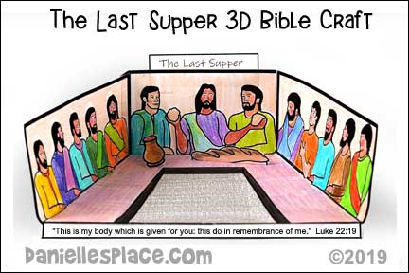
Material:
*Template printed out
*Colored Pencils or crayons

*Glue or Clear Tape
*Pencils or Pens
*Scissors

Directions:
1. Print out the patterns and make copies (next page)

2. If you have younger children or limited time, cut out the patterns.

3. Have your children color the pictures and cut them out. To make the 3D display, cut only on the thick black lines. Fold all three sides up. Fold the tabs on the middle section up.

4. Place glue on the tabs and stick them to the back of the pattern so that it forms a box.

5. Fold the tabs on the bottom of the wine and bread pictures back and glue the pictures to the table in front of Jesus.

6. If you have older children, you can have them write the names of each of the disciples next to the pictures of the disciples or have them make conversation bubbles about what Jesus and the disciples said and glue them next to the disciples.
